

EC-200 Data Structures
LAB MANUAL # 12

Course Instructor: Dr. Anum Abdul Salam

Lab Engineer: Engineer Hira Irshad

Student Name: _______________________________________________

Degree/ Syndicate: ____________________________________________

 | Trait | Obtained Marks | Maximum Marks
R1 | Application Functionality 20% |  | 20
R2 | Specification & Data structure implementation  30% |  | 30
R3 | Reusability  10% |  | 10
R4 | Input Validation  10% |  | 10
R5 | Efficiency  20% |  | 20
R6 | Delivery  10% |  | 10
R7 | Plagiarism above 60% |  | 0
 | Total |  | 100

Total Marks = O𝒃𝒕𝒂𝒊𝒏𝒆𝒅 𝑴𝒂𝒓𝒌𝒔 (∑⁶_{𝟏} 𝑹_{𝒊} ∗ 𝑹₇)

Lab # 12: GUI in C++

Lab Objective:
To implement GUI in C++
Lab Description:
When starting programming we always output the outcome of the program on the console. This is good for small program and for learning programming purpose. But when the program become bigger and have several outputs, or requires some graphic output it becomes necessary to create graphical user interface (GUI). For most engineering program we need to change many parameters each time we run a program. The use of well designed graphical interface make this task easy and lest tedious.
Pre-Setup
In order to create a GUI project, you must open the Visual Studio installer and verify that the “C++/CLI Support” option is enabled as seen in the picture below.
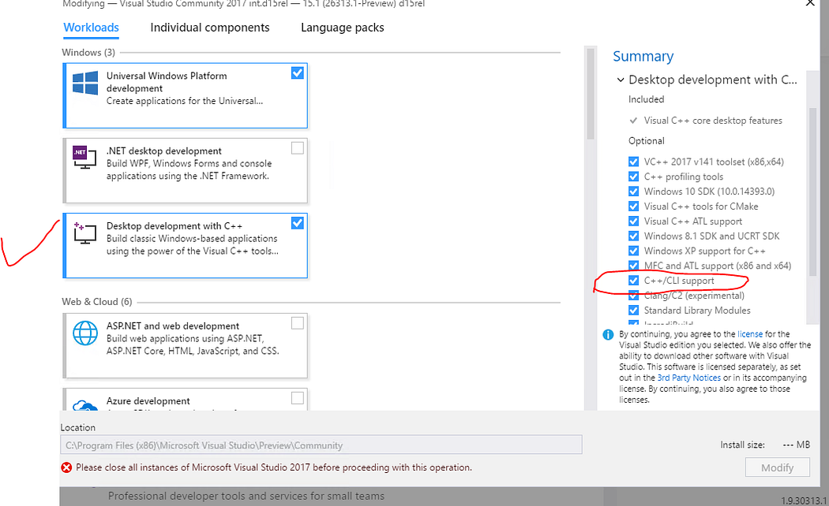
This option is not enabled by default so if you already have Visual Studios installed, open the installer, enable “C++/CLI Support” and then press the modify button to update your Visual Studio features.

Create Project:
Create a new project in Visual Studio using CLR Empty Project(.NetFramework) as project template.
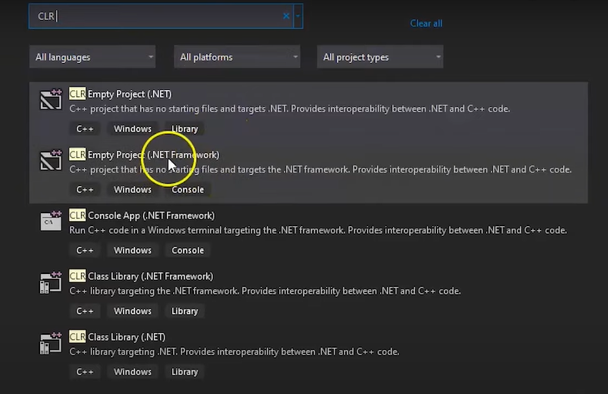
Creating Windows Form Application
As the project has been created, now you will build a windows form application and for that, you must create a form file. Click on this Project icon in the upper bar and select Add New item.
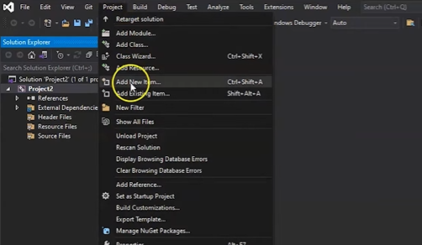
After this step, select UI under Visual C++, click on the Windows form, and press ‘add’ to open the form file.
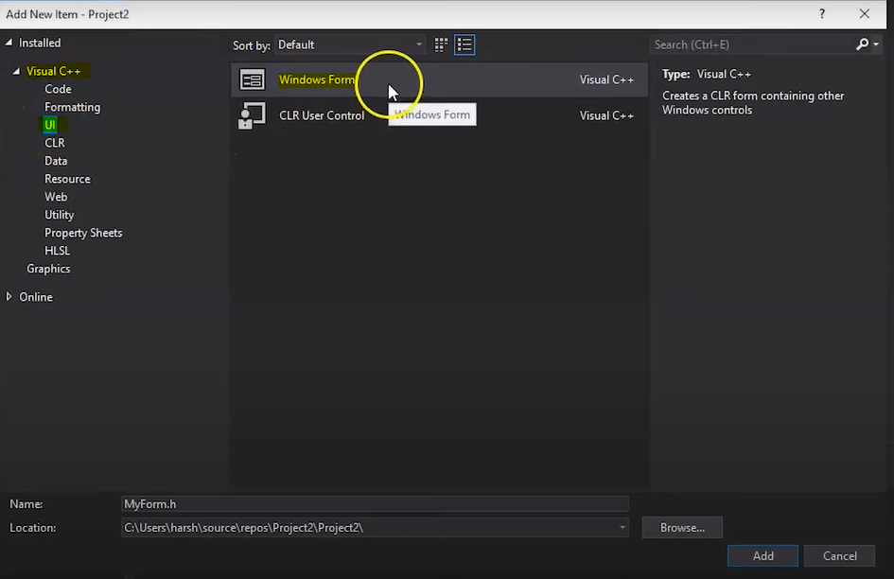
Now, you will do some additional configurations. Again you must click on Project -> Properties, it will open the configuration properties, and select Linker from there, and from the drop-down, click on System. On clicking the system the subsystem option will appear, and you have to select that from the drop-down because the Subsystem tells the operating system how to run the .exe file. You will have to select Windows from the drop-down bar.
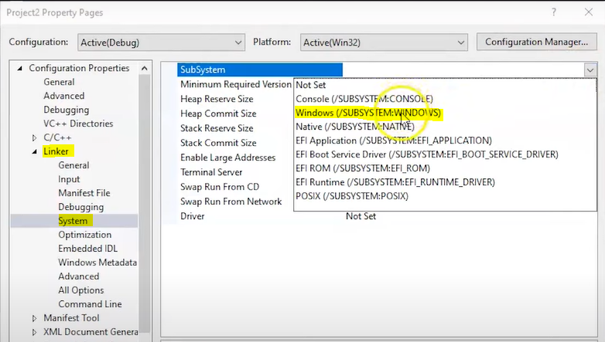
After this step, you have to select the entry point. So under configuration settings, choose Advanced and write Entry point as main and click on ok. The entry point means the starting address of .exe file.
Once the configurations are done, click on the Myform.cpp file from the left bar and add the code in this file.
Code:
#include "MyForm.h"
using namespace System;
using namespace System::Windows::Forms;
[STAThread]
void main(array<String^>^ args)
{
Application::EnableVisualStyles();
Application::SetCompatibleTextRenderingDefault(false);
MyProject::MyForm form;
Application::Run(% form);
}
You can paste the above code in the .cpp file. This code shows how the program will execute; MyProject is the project's name; you have to change it according to your project name. Similarly, MyForm is the name of the form file; you can change it as well according to the name of your form file and save it.
Now, click on Myform.h and the windows form will appear as shown in the figure below.
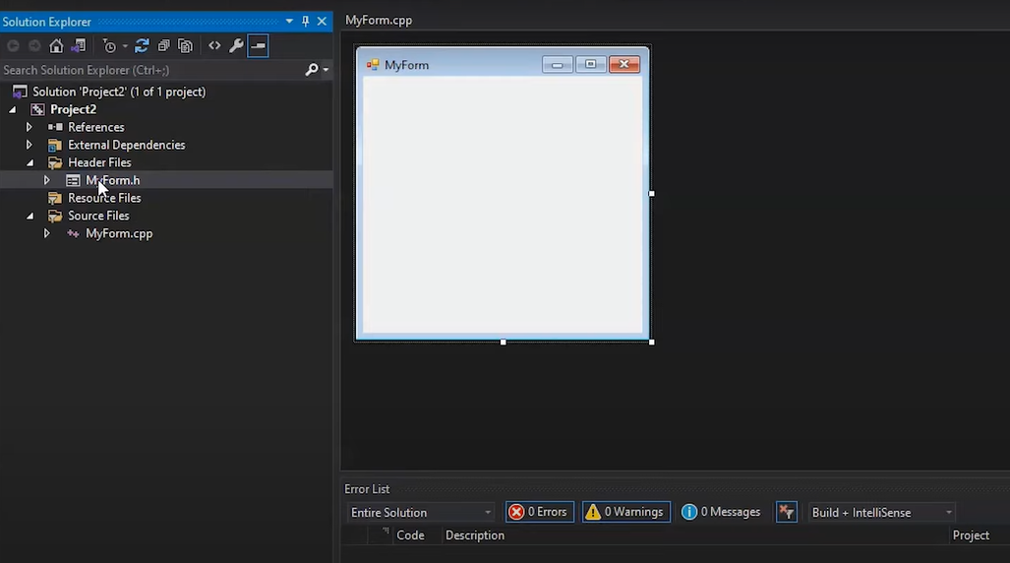
Now, you can check the form by running it, so you can click on the Local Windows debugger button, and if it is running fine, you can proceed to add GUI elements to the windows form. Go to VIEW –> ToolBox. The ToolBox will open. It contains all we need to create an interactive GUI.
Lab Task:
Develop an interactive GUI Dictionary Management Application using Trie that allows users to:
- Add and delete words
- Search words
- Explore words by prefix
- Interact with suggestions dynamically
The application must be implemented using a variety of GUI components and event-driven interactions.
You can use following GUI elements in your application.
- TextBox for word input
- Buttons for Add / Delete / Search
- Label for result/status message
- ListBox for displaying suggestions
- Auto-fill textbox for when user click or double-click a suggestion
- CheckBox for Case Sensitive search
- Radio Buttons to allow user to choose how search is performed: Exact word search or prefix search.
- ComboBox controls how many suggestions are displayed. For example, 5 suggestions, 10 suggestions, 15 suggestions, etc.

